FLOW LOGIC

PROGRAM LINES JUST LIKE SE38

LOOP

COMMAND

ALTERNATIVES

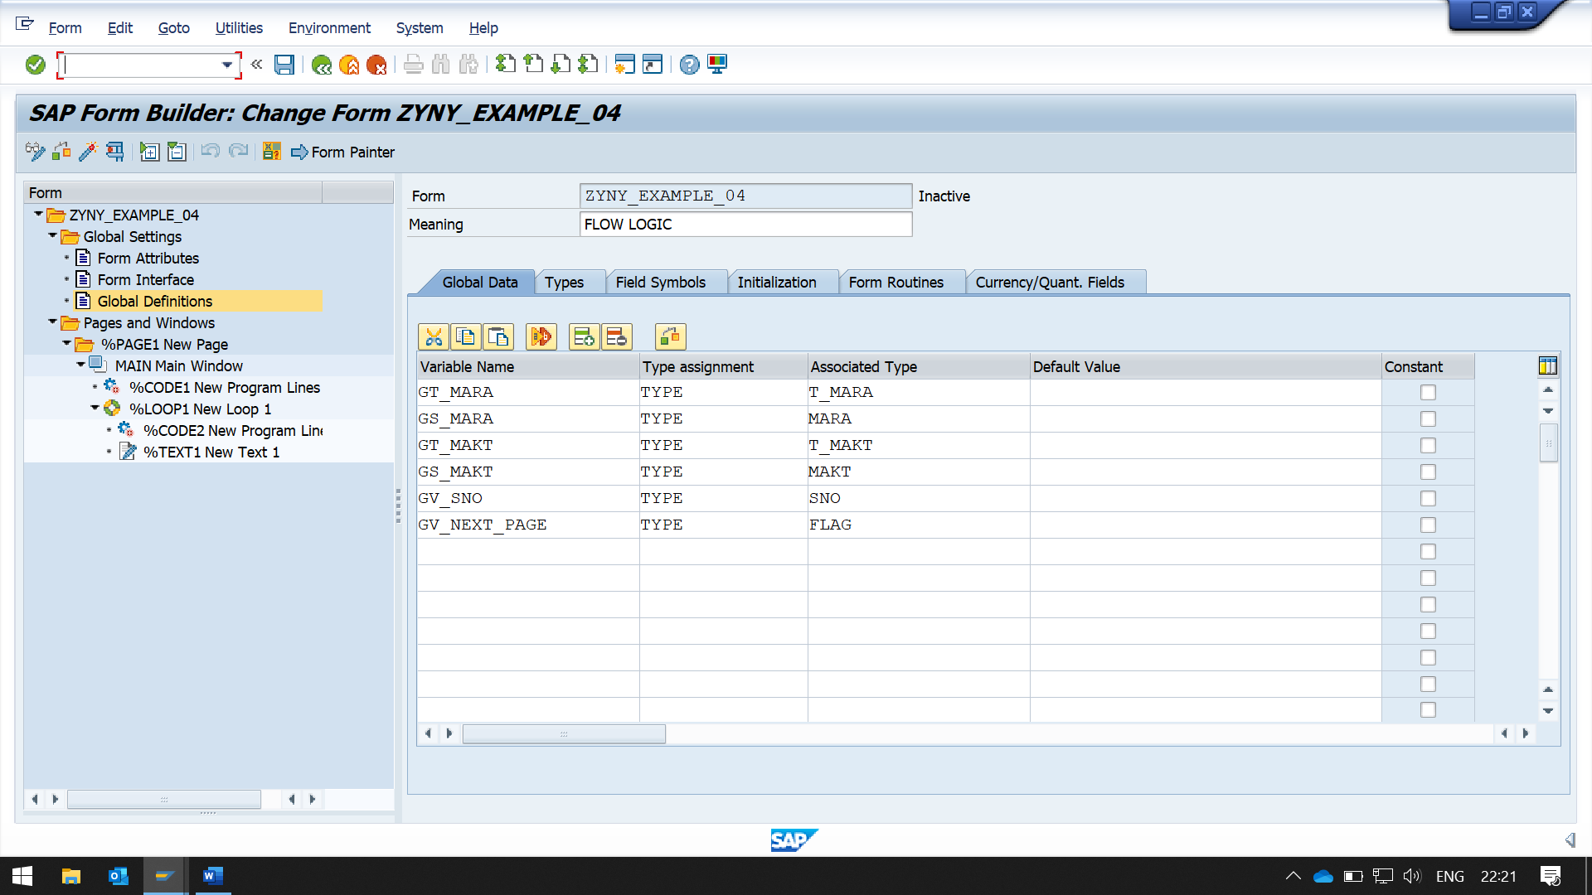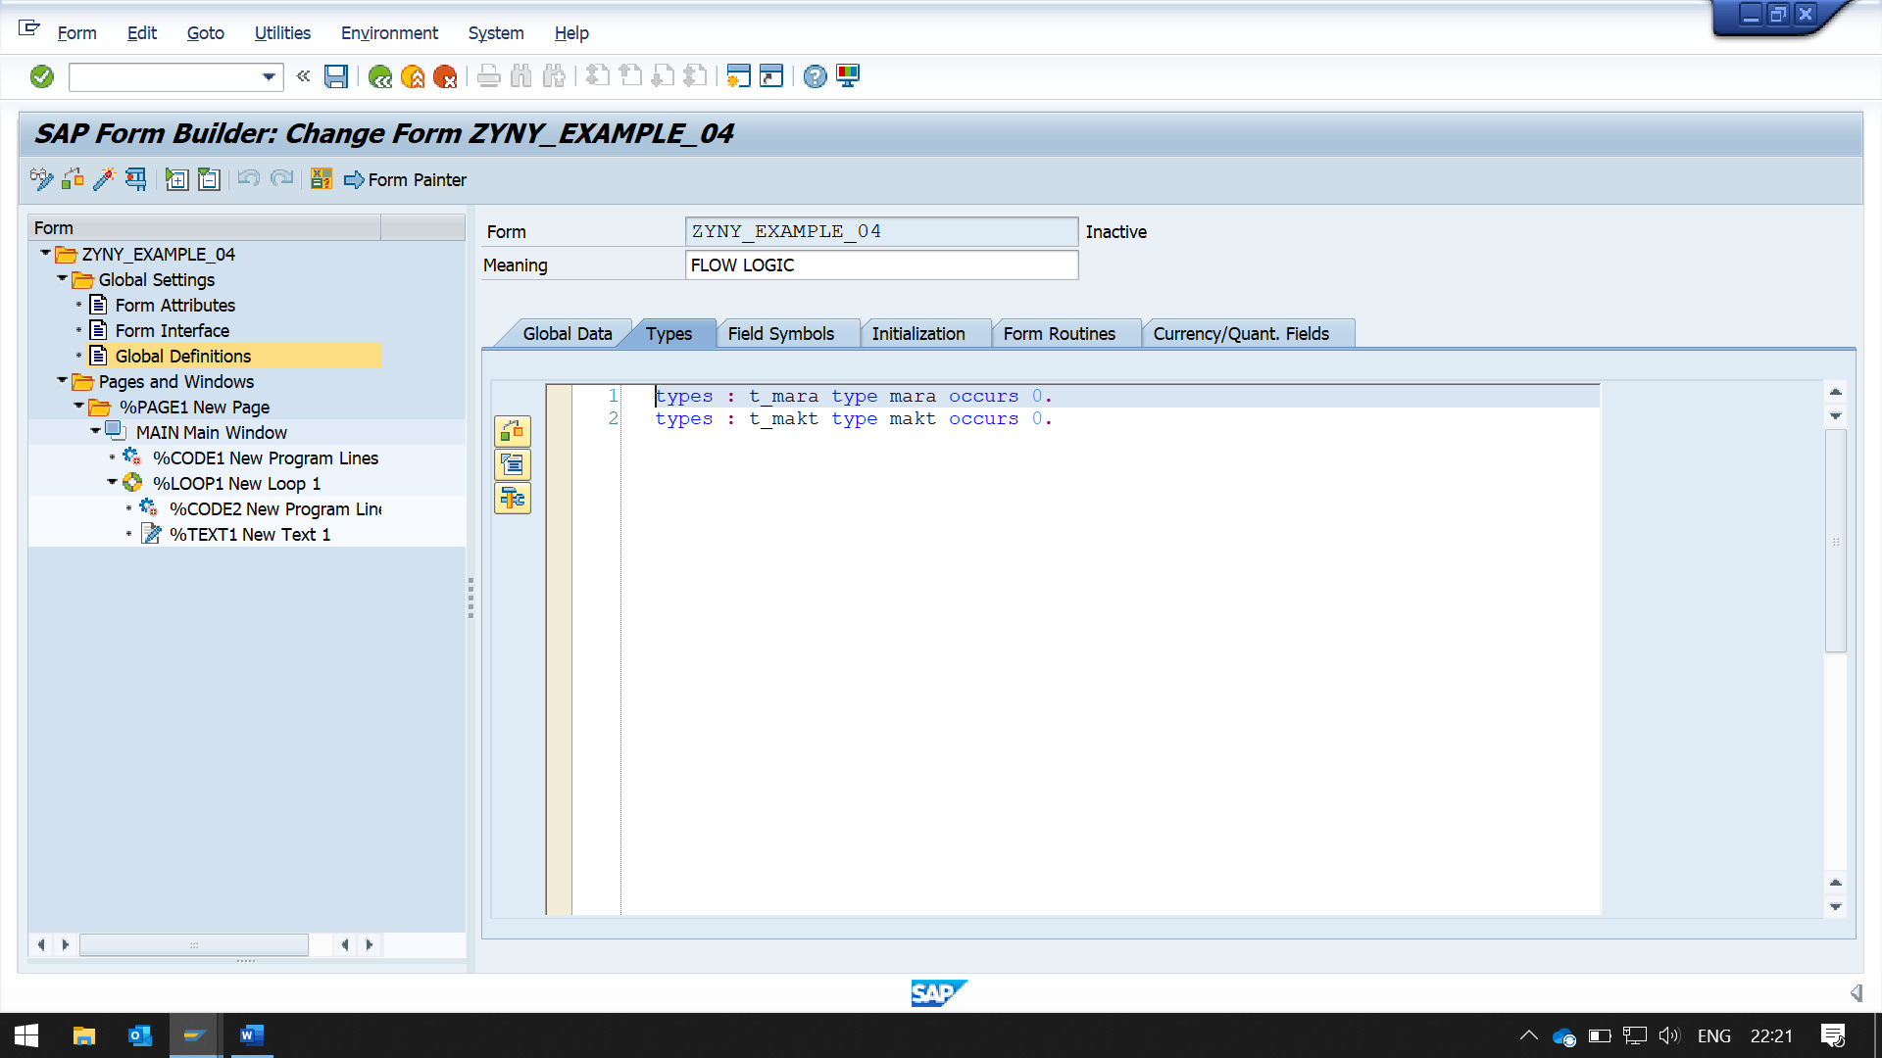types : t_mara type mara occurs 0.  
types : t_makt type makt occurs 0.

NOW CREATE A PROGRAM LINE

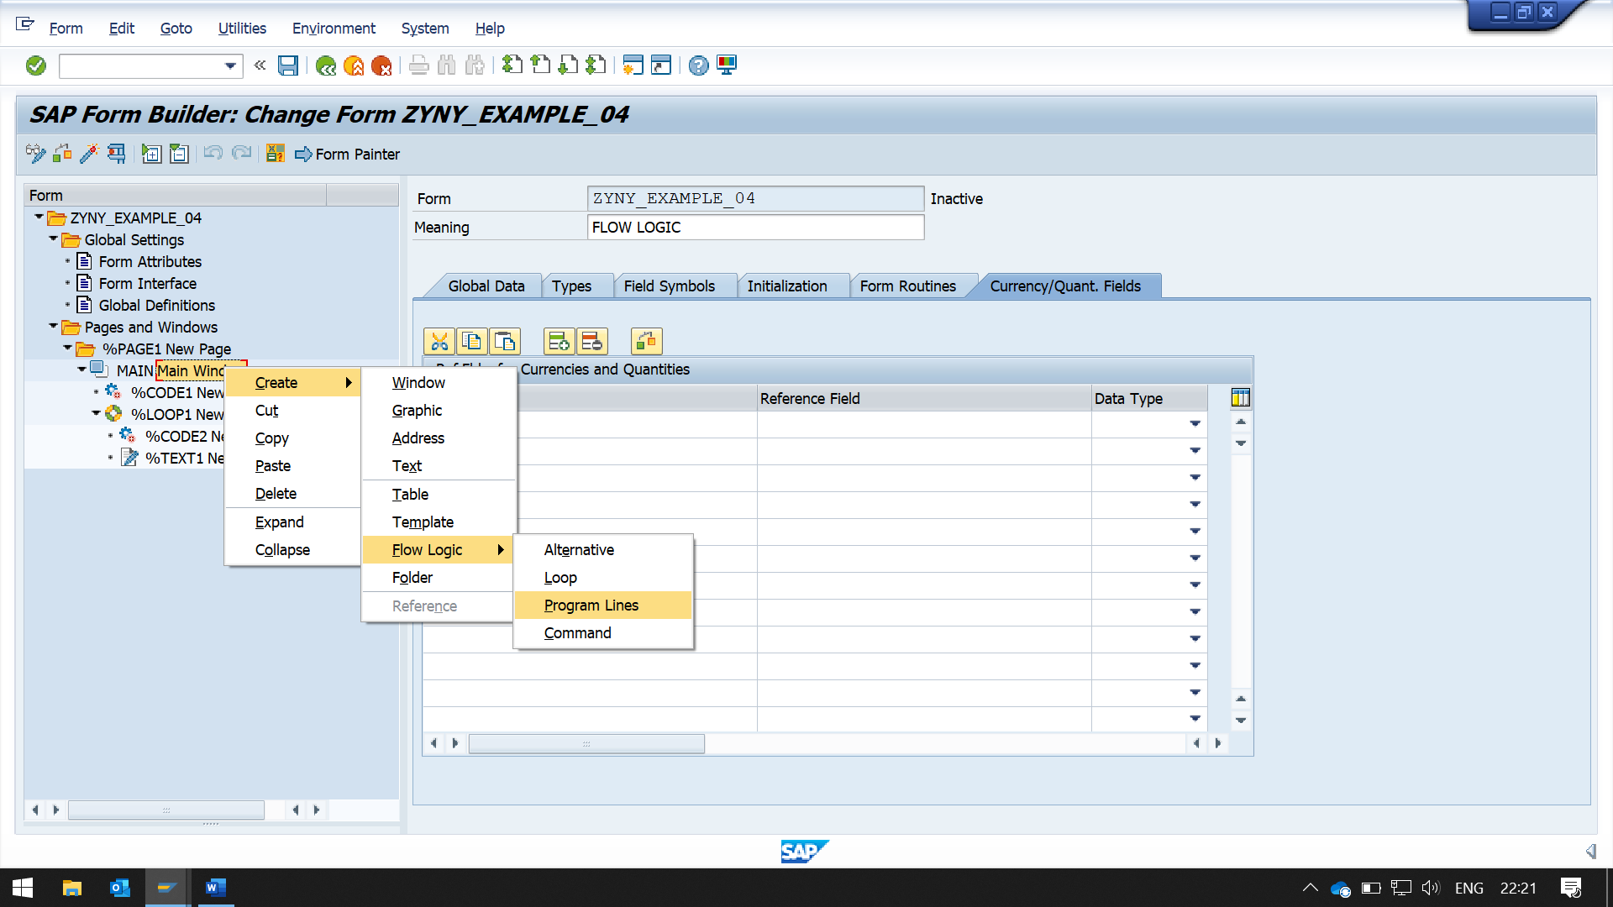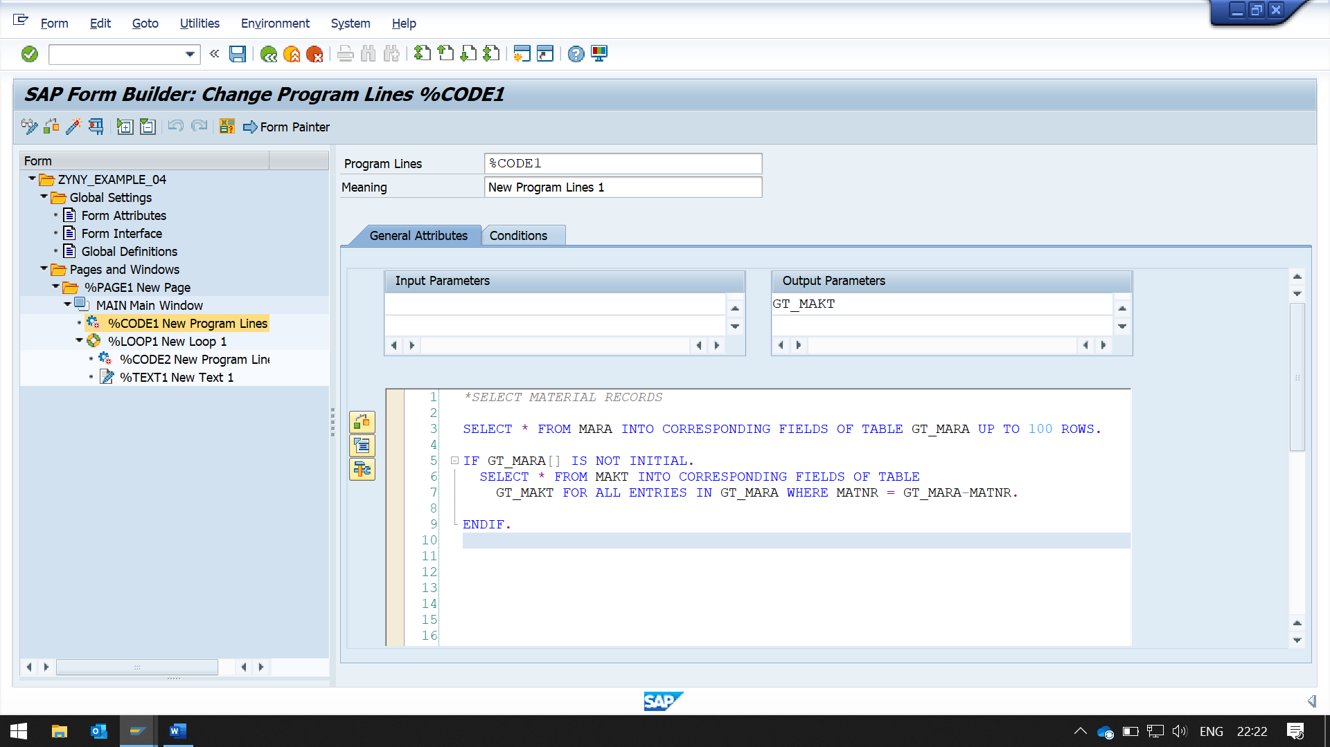*SELECT MATERIAL RECORDS  
  
SELECT * FROM MARA INTO CORRESPONDING FIELDS OF TABLE GT_MARA UP TO 100 ROWS.  
  
IF GT_MARA[] IS NOT INITIAL.  
  SELECT * FROM MAKT INTO CORRESPONDING FIELDS OF TABLE  
    GT_MAKT FOR ALL ENTRIES IN GT_MARA WHERE MATNR = GT_MARA-MATNR.  
  
ENDIF.

NOW CREATE A LOOP FOR INTERNAL TABLE DATA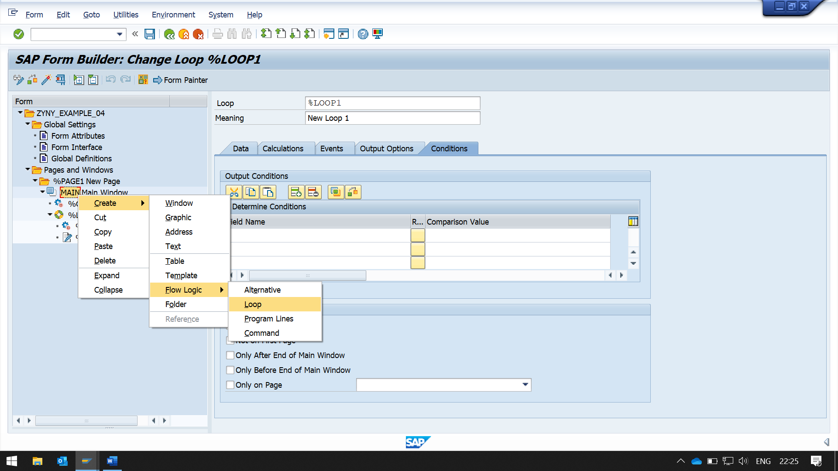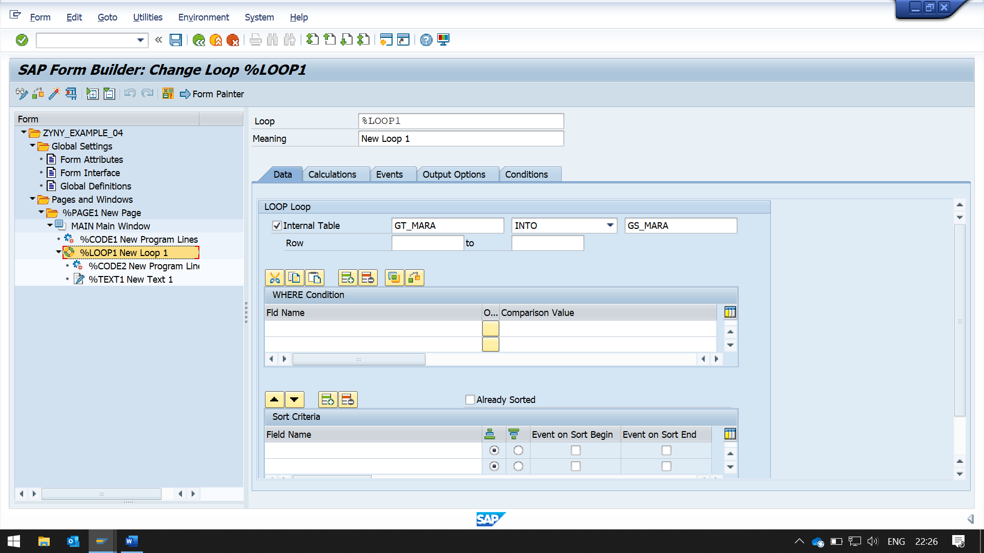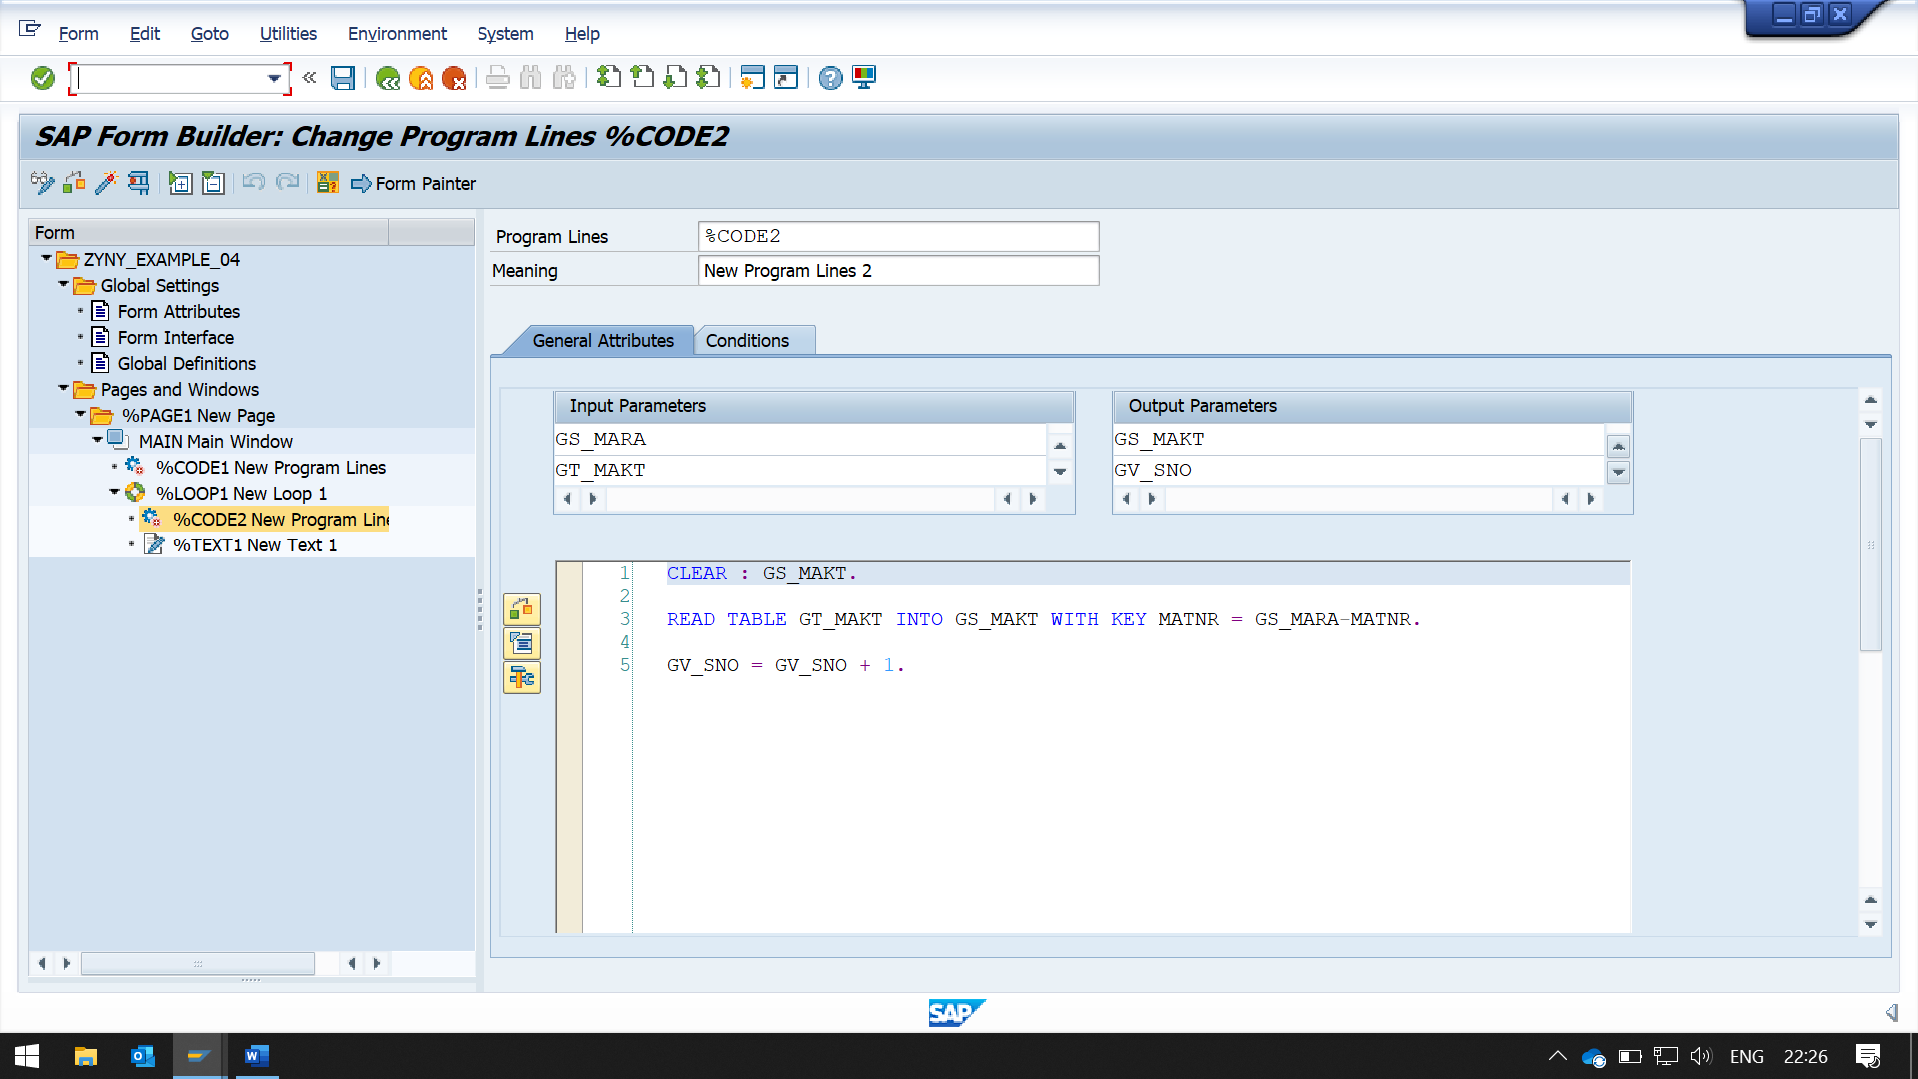TAKE CLOSE LOOK AT OUTPUT PARAMETER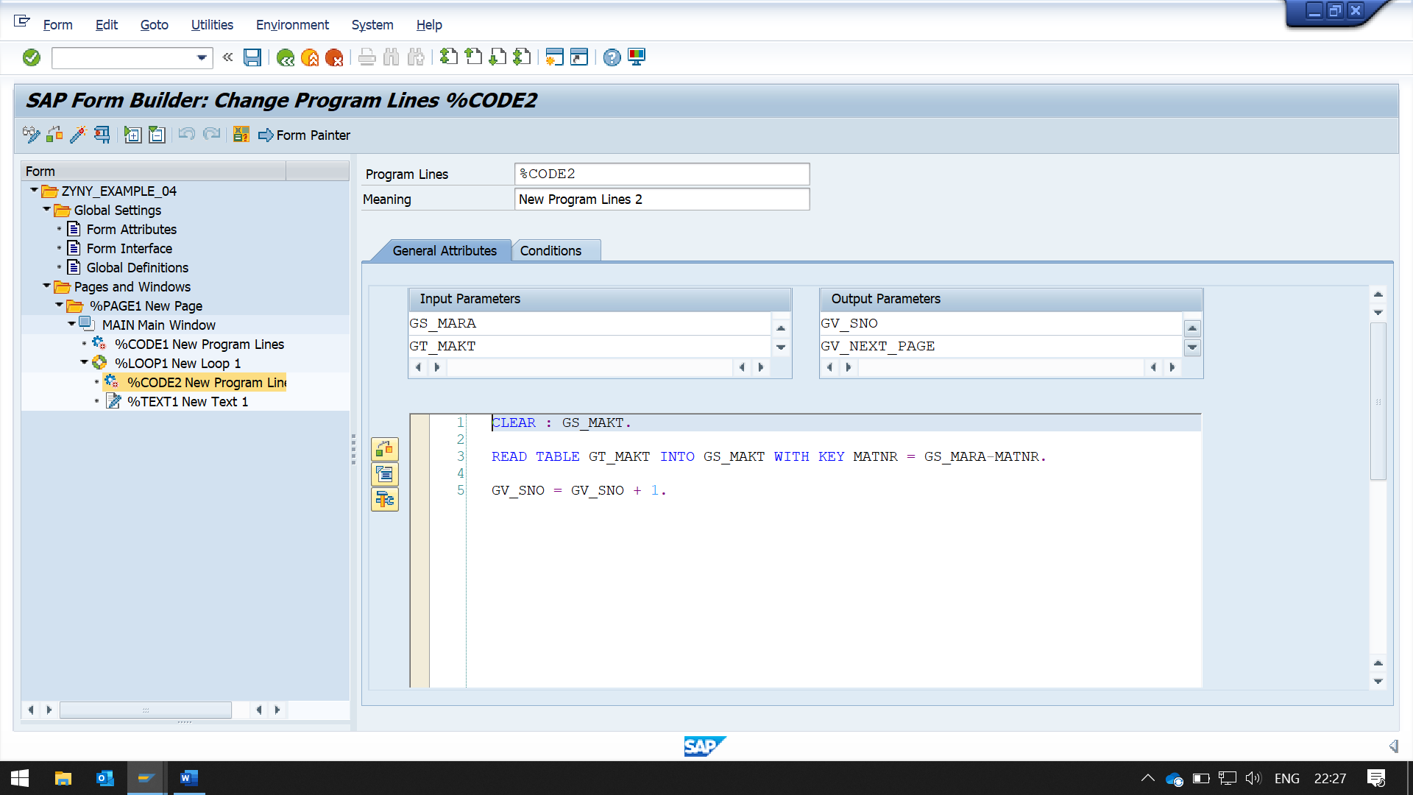

NOW CREATE A TEXT IN LOOP, TO PRINT TABLE DATA

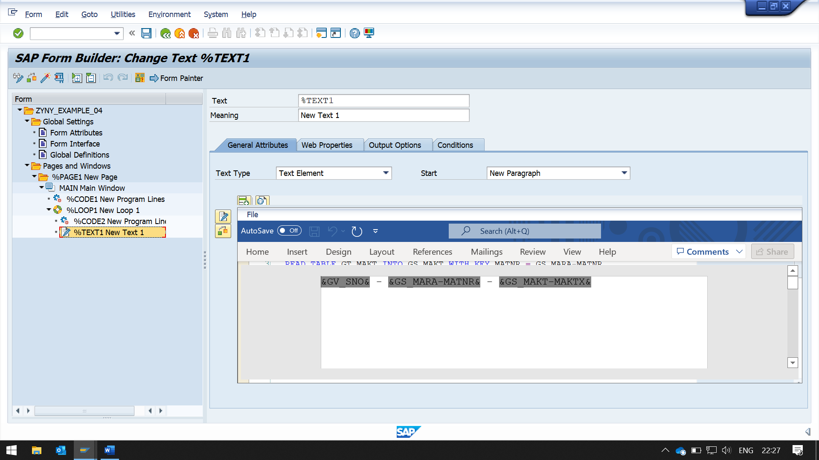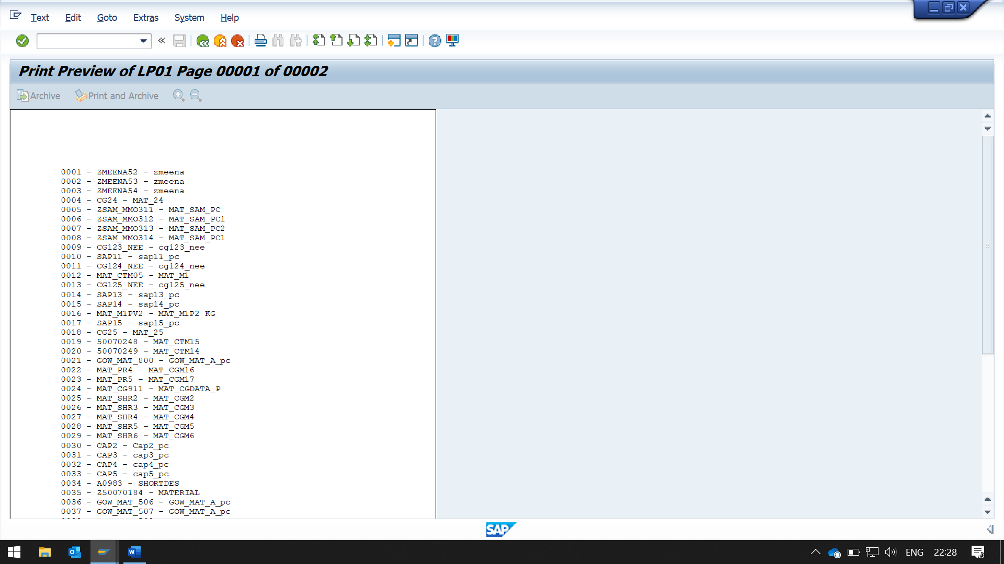

NOW ILLUSTRATION FOR COMMAND

NOW WE ARE PRINTING ONLY 10 RECORDS ON ONE PAGE, IF 10 RECORDS ARE PRINTED THEN REMAINING RECORDS SHOULD BE SHIFT TO NEXT PAGE

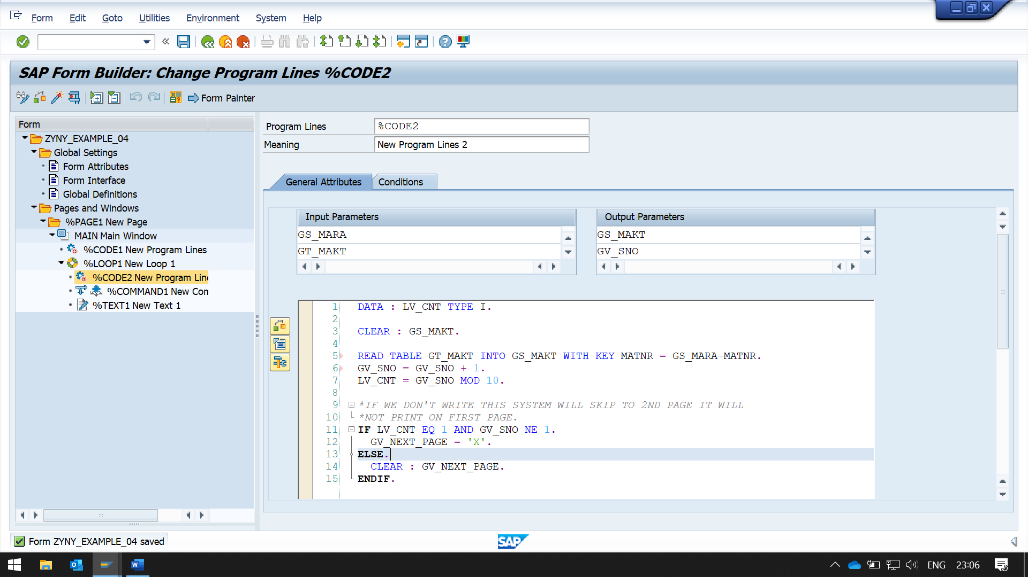DATA : LV_CNT TYPE I.  
  
CLEAR : GS_MAKT.  
  
READ TABLE GT_MAKT INTO GS_MAKT WITH KEY MATNR = GS_MARA-MATNR.  
GV_SNO = GV_SNO + 1.  
LV_CNT = GV_SNO MOD 10.  
  
*IF WE DON'T WRITE THIS SYSTEM WILL SKIP TO 2ND PAGE IT WILL  
*NOT PRINT ON FIRST PAGE.  
IF LV_CNT EQ 1 AND GV_SNO NE 1.  
  GV_NEXT_PAGE = 'X'.  
ELSE.  
  CLEAR : GV_NEXT_PAGE.  
ENDIF.

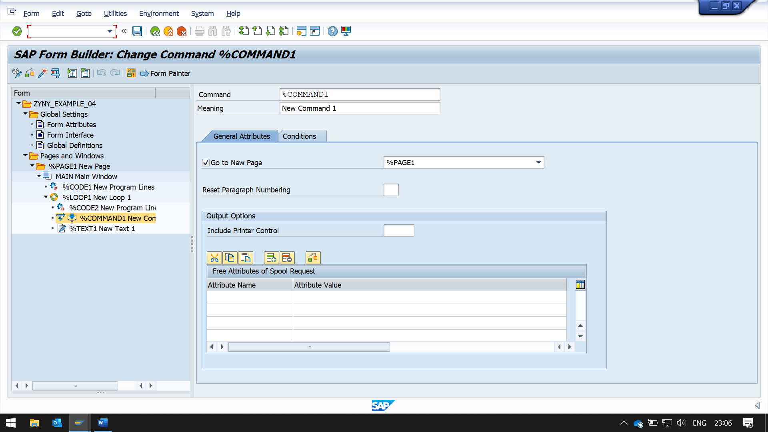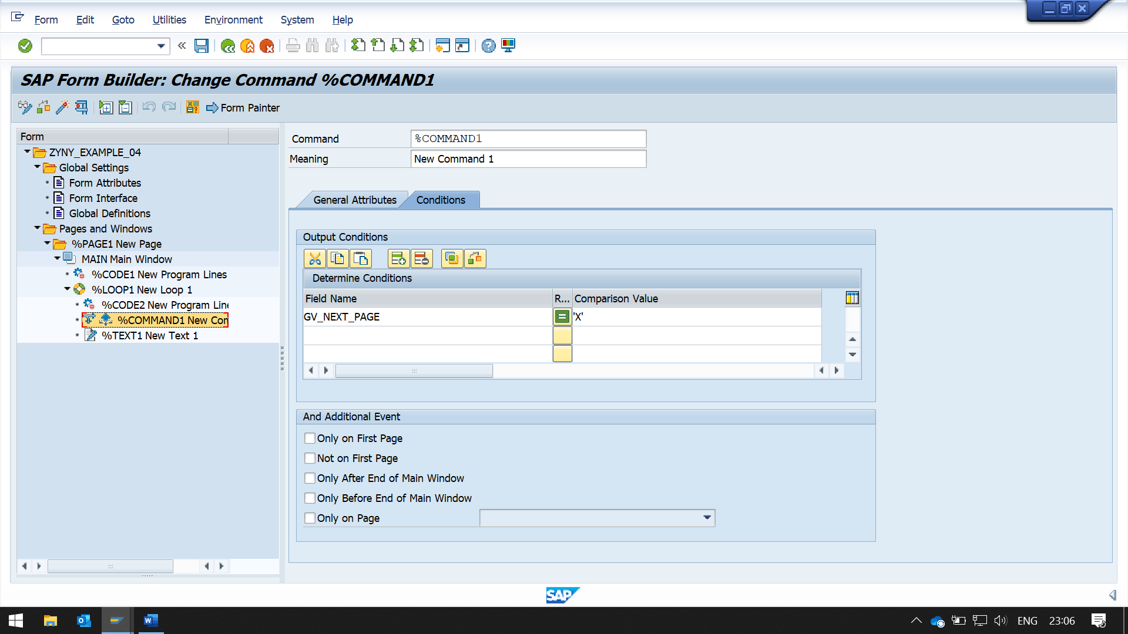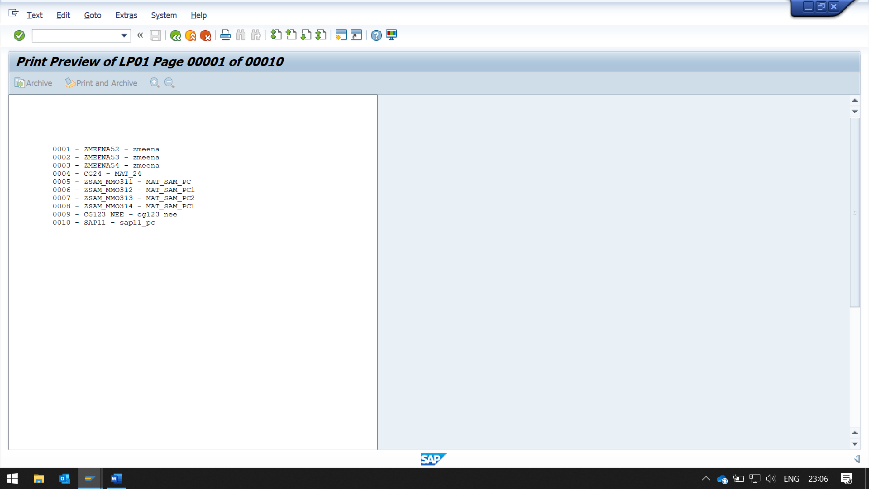

Alternative

Now create alternative 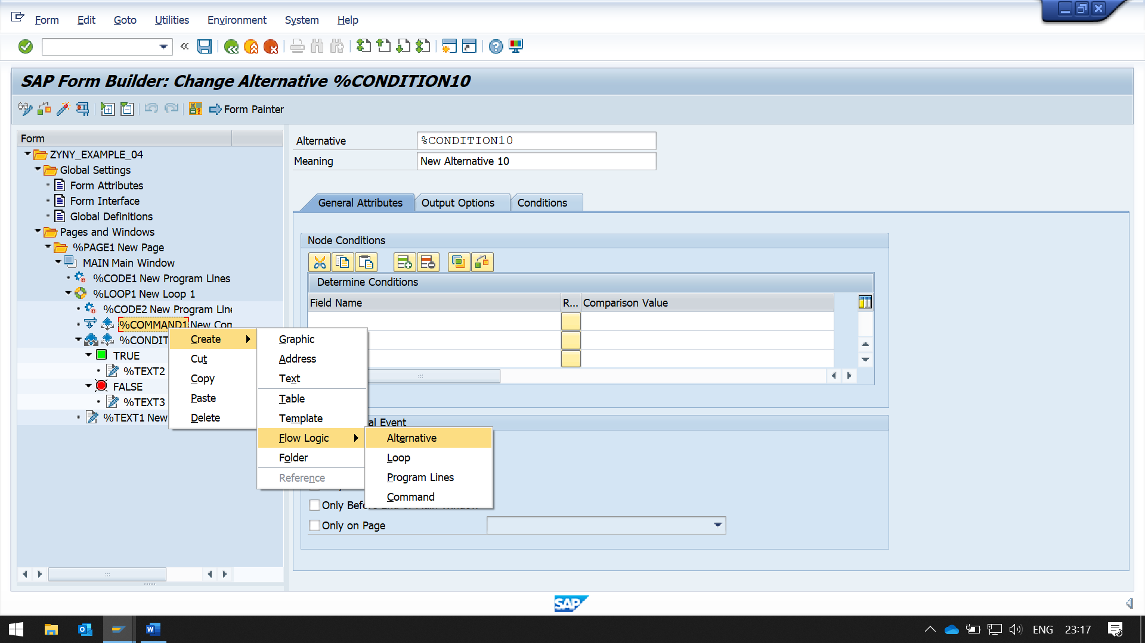

In True, create a text for true statement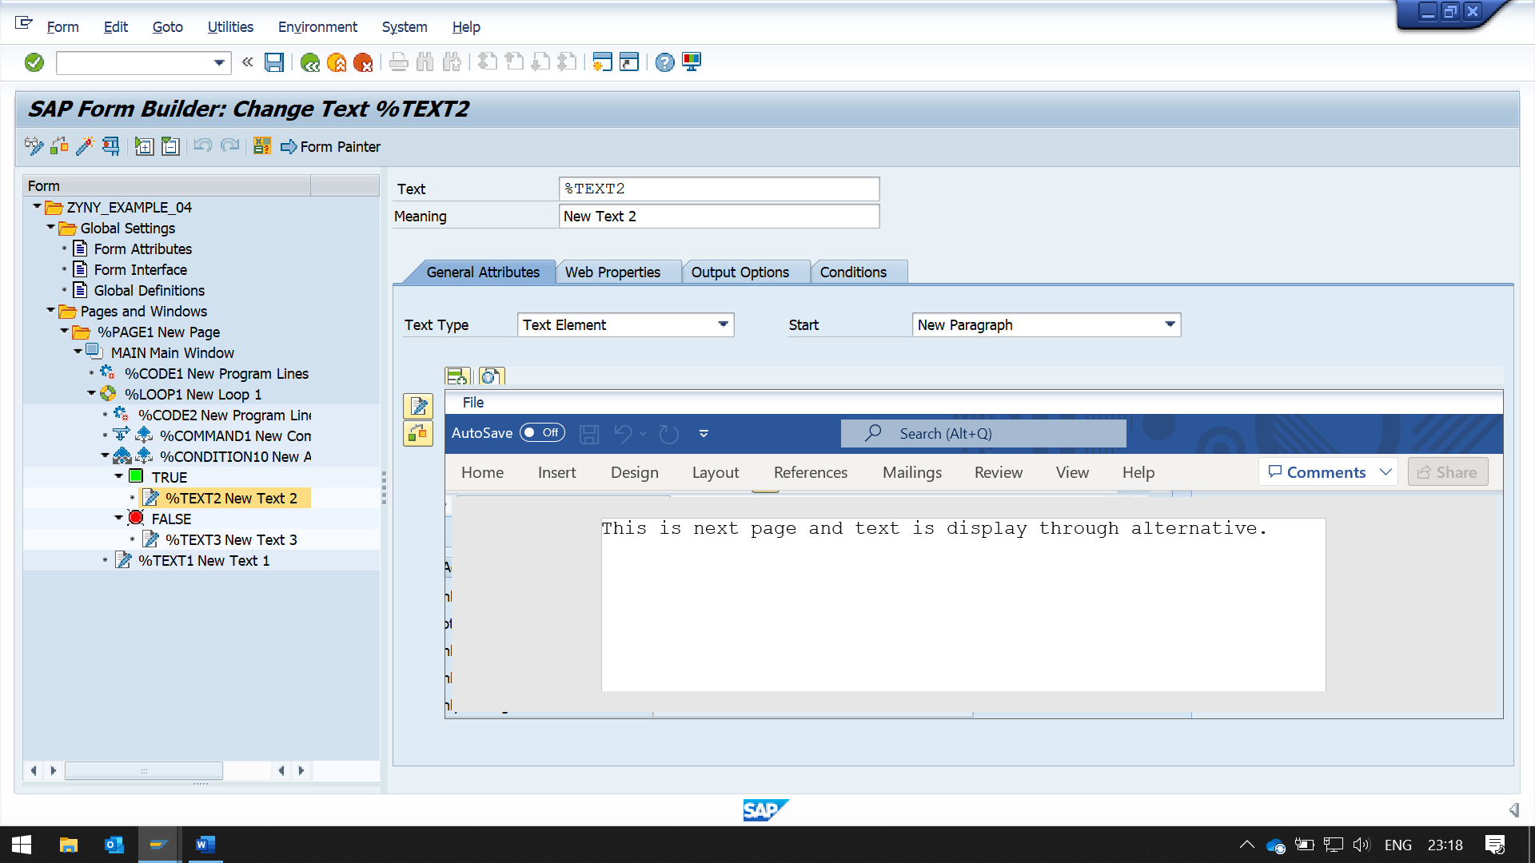

In False, create a text for false statement 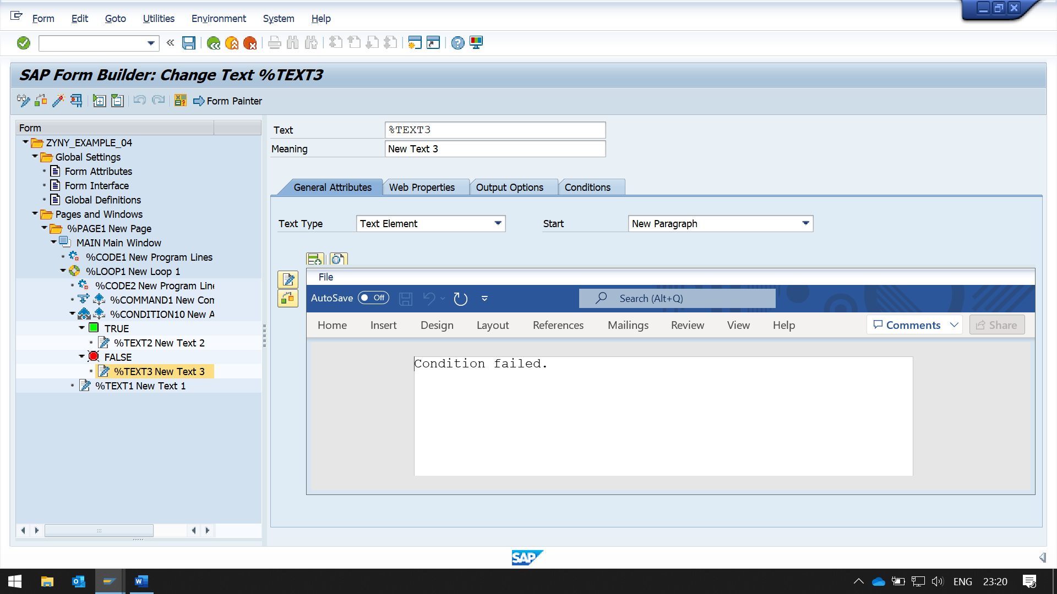

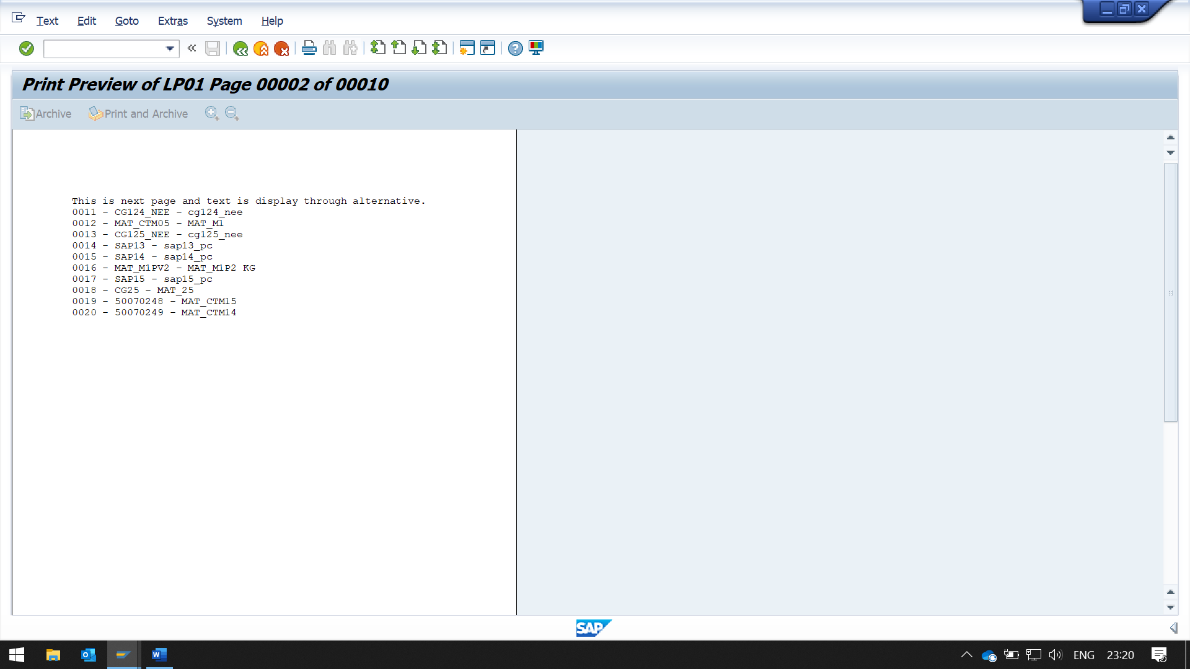

I don't know for some reason, output was not as expected false statement was not triggering

